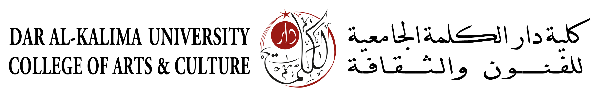

International tourism experts visit the new Community Hotel established by Dar al-Kalima University College in Bethlehem’s Historic Center
Bethlehem, Palestine – From 14th Nov. to 17th of November 2016 Dar al-Kalima University College of Arts & Culture hosted a group of 21 international tour operators, tourism representatives, travel journalists, and tourism development expects from Italy, Spain, and Malta for an Educational Tour and FAMtrip on the occasion of the establishment of the new Community Hotel in Bethlehem’s Historic Center.
The establishment of this new kind of accommodation in Bethlehem is the pilot action of the multi-country EU-funded project called “Future of Our Past”. In this project Dar al-Kalima took a pioneering role in envisioning the concept of the Community Hotel, in which individual travelers will experience Palestine’s extraordinary hospitality alongside with the intimacy and authenticity of dwelling in rehabilitated historic apartments within Bethlehem’s Historic Center.
After a year-long process of planning, rehabilitation, and networking with the local community, Dar al-Kalima successfully rehabilitated the first five apartments spread throughout the Historic Center of Bethlehem and shared the core values of the FOP project with numerous local accommodation providers, who all together strive for a better accommodation and touristic experience in Bethlehem. The total capacity of beds offered under the trademark of the Community Hotel will shortly reach almost 70, with more beds and more apartments in the planning and implementation phase.
The main purpose the Education Tour was to present the apartments of the Community Hotel as well as the newly established Information Center in the International Center of Bethlehem (Dar Annadwa) to the international tourism market and create a current for the promotion of Bethlehem and Palestine.
The tour started with a welcoming event hosted by the International Center of Bethlehem with a multimedia presentation about the concept of the Community Hotel and the potential of Palestinian tourism in general.
In the following days, the participants joined a panoramic tour through Bethlehem, Beit Sahur, Beit Jala, Battir, and finally to Jerusalem learning about Palestine’s cultural richness and potential as a travel destination. Besides classical touristic “hotspots” the program especially targeted less often visited, yet important sites such like the Bethlehem Museum, AIDA camp, or the UNESCO World Heritage Site Battir. In the latter, the group enjoyed a locally made lunch and was introduced to Palestine’s potential as a culinary destination.
In the concluding dinner, all participants agreed that the potential of Palestinian tourism is far greater that what is currently available on the international market in matters of tour offers and marketing efforts. Many of the participants confirmed their interest to add Palestine to their touristic portfolio or to return for a more extensive journalistic coverage of its touristic offer.
As the host of this event, Dar al-Kalima University College of Arts & Culture would like to thank all involved parties in making this important event possible. As an institution primarily striving to support the local community in Bethlehem and all Palestine, Dar al-Kalima will continue its efforts to explore and promote new segments of tourism.

